**The relationship between Crime, Poverty and Unemployment in the states of the USA in 2020**

Karthikeya Nalluri, Anindita Mukerjee, Aditya Salunkhe

 Economics, Carl H. Lindner College of Business, University of Cincinnati

**ABSTRACT**

We analyze the relationship between the variables: crime; burglary (per 100,000 inhabitants) poverty and unemployment, state wise in the USA, in the year 2020. We use crime as a dummy variable (for burglary  individually). Our models to find the relationship between our dependent variable; crime, and our independent variables; poverty and unemployment, include SAR in R. We find  a statistically significant relationship between crime and poverty and a statistically insignificant relationship between crime and unemployment which was unexpected. There is a role of poverty with the increase in crime rates in the states in the USA.

**Keywords**: Spatial auto-regressive model

1. **Introduction**

In 2020, the USA stood 50th amongst 129 countries, with a crime index of 47.20.1 We focus our crime analysis on burglary (per 100,000 inhabitants) ; state wise, as our dependant variables out of the different classes of crime as our empirical model is data intensive, requiring the combination of large datasets. We analyze direct, indirect effects in this model. Our interest in burglary striked in particular as that is one of the most common types of crimes in the USA.2 The importance of this analysis is to establish a data driven model to draw the relationship between crime, poverty and unemployment and how concentrating on uplifting poverty and unemployment can help reduce the crime rates across the USA. The state wise model can give a comprehensive insight for the same. As COVID hit the world (2019,2020), we could see mass unemployment and poverty stricken areas hurt the most 3,4 which makes the period across 2020 a good time period to analyze the cross sectional study of crime with respect to our independent variables.5 Using SAR we interpret our analysis.

1https://www.numbeo.com/crime/rankings_by_country.jsp?title=2020&displayColumn=0

2https://westerlaw.org/the-10-most-common-crimes-in-the-united-states/

3https://www.hindustantimes.com/business-news/covid-19-pandemic-s-worst-impacts-on-poverty-yet-to-come-says-un-expert/story-PcdrX7CYlvi4gIRWStn8hJ.html

4https://news.un.org/en/story/2021/06/1093182

5Rate of unemployment and poverty in the period of 2020 in the USA, statewise.

1. **Spatial auto-regressive probit model**

We take Y* as crime which is our latent variable and poverty and unemployment as our independent variables. Taking Crime as a dummy variable gives us a LPM model -

**Y* = crime* = poverty + unemployment   (A)**

The latent variable, Y* = crime*, explains the effects of poverty and unemployment. The dependent variable crime is a dummy variable, and

**Crime = 1 ; if residential burglaries per 100,000 households is above 300**

**= 0 ; otherwise**

We analyze the dummy when the residential burglaries are above 300 and otherwise.

Spatial Probit model includes spatial dependency in the LPM model. We can explain it by -

**Y* = ρWY* + Xβ + € , € ~ N(0, σ2)   (B)**

The spatial lag of the latent dependent variable WY* involves the spatial weight matrix W that contains elements consisting of either 1=m or 0, where m is some number of nearest neighbors.

The reduced form of (B) is

Y* = (I - ρW)−1 (Xβ + €)

Assuming the k nearest neighbors to be 5, the following results have been formulated. 

1. **Results and Discussion**

**3.1    Summary table for SAR probit model**

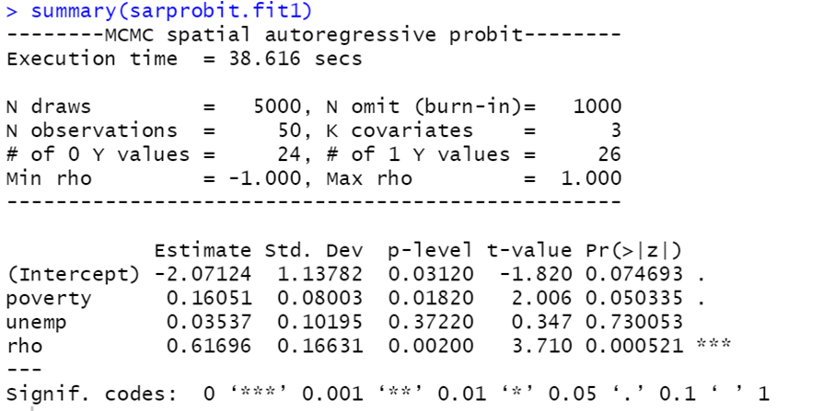

**Table 1: Summary of the SAR probit model**

From Table 1, it can be observed that poverty is significant at 10% significance level and rho is also significant. Unemployment is not significant.

It can be observed that crime is affected by poverty positively and is not affected by unemployment in the state.

Rho captures the spatial dependence and indirect effects and has the values between -1 to 1. It can be observed that the crime is more likely to increase in one state when the crime in neighboring states increases.

**3.2    Direct, Indirect and Total Effects in SAR probit model**

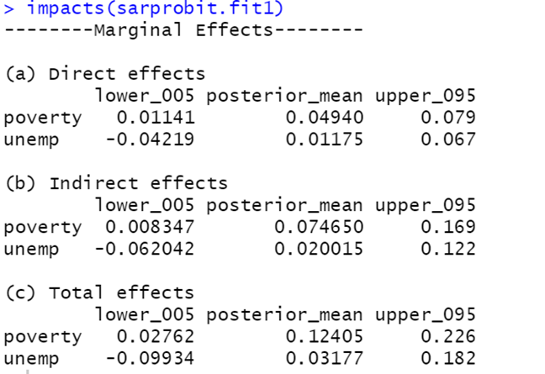

**Table 2 : Direct, Indirect and Total Effects in SAR probit model**

From Table 2, we can observe the direct and indirect and total effects.

From the direct effect, it can be observed that by increasing the poverty rate in one state, it is affecting the crime rates in the respective state. Direct effect captures the marginal and feedback effect. Unemployment has minimal effect or insignificant effect on crime.

Indirect effect is the spillover effect that the neighbors have on each state. From the indirect effect, it can be observed that the significant change in poverty rate in neighboring states is positively affecting the crime in the given state. Indirect effect explains the spillover effect. Unemployment does not have any indirect effect on crime.

Total effect = Direct effect +Indirect effect.

It can be observed that the poverty and unemployment rate in neighboring states have more impact on crime in one respective state as the indirect effects are more than the direct effects.

**3.3. Different plots**

It can be observed that the distribution converges immediately.

From the above plots, in Posterior distribution of Rho, it can be observed that the distribution is skewed towards right.

**3.3   Comparing results with LPM model**

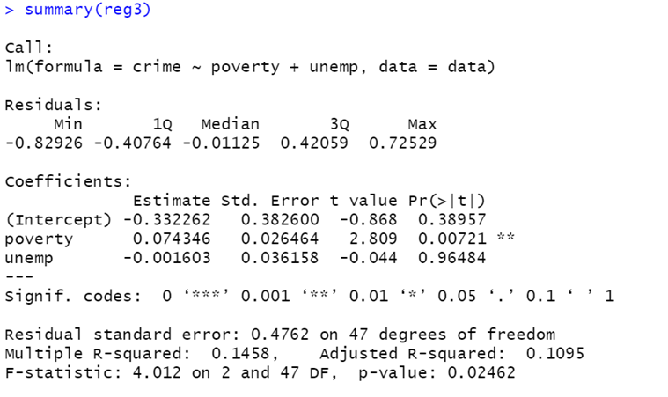

**Table 3: Comparing the results with the LPM model**

From Table 3, the LPM model, it can be observed that poverty is significant, but unemployment is insignificant. Even though unemployment is insignificant, it has negative sign when compared to spatial probit model.

LPM and spatial probit model provides the same results, but spatial probit model provides the spatial effects (direct and indirect effects)

1. **Conclusions**

Statistically, the rate of poverty is positively correlated to the rate of crime(rate of burglary per 100,000 inhabitants) which proves that as burglaries increase in the states of the USA, the rate of poverty also increases. The states having more poverty proved to have more crimes. The significant change in the rate of poverty in neighboring states is positively affecting the rate of crime in the given state. Indirect effect explains the spillover effect. However, the rate of unemployment in the states are not significant and uncorrelated with the rate of crimes in the states. We observe that the poverty and unemployment rate in neighboring states have more impact on crime in respective states as the indirect effects are more than the direct effects. The insignificance in unemployment can be explained by the small sample size while comprehensively analyzing the states of the USA else it's for future prospects to find out.  While we can say that statewise across the USA our observations are true, our study does not cover the individual states with their own biases like state laws and  inconsistency in reporting burglaries.

**5. References**

[1] Anser, Muhammad Khalid, Zahid Yousaf, Abdelmohsen A. Nassani, Saad M. Alotaibi, Ahmad Kabbani, and Khalid Zaman. “Dynamic Linkages between Poverty, Inequality, Crime, and Social Expenditures in a Panel of 16 Countries: Two-Step GMM Estimates - Journal of Economic Structures.” SpringerOpen. Springer Berlin Heidelberg, June 5, 2020. https://journalofeconomicstructures.springeropen.com/articles/10.1186/s40008-020-00220-6.

[2] Schleimer, Julia P., Veronica A. Pear, Christopher D. McCort, Aaron B. Shev, Alaina De Biasi, Elizabeth Tomsich, Shani Buggs, Hannah S. Laqueur, and Garen J. Wintemute. “Unemployment and Crime in US Cities during the Coronavirus Pandemic - Journal of Urban Health.” SpringerLink. Springer US, January 27, 2022. https://link.springer.com/article/10.1007/s11524-021-00605-3.